PHYSICS 2006

YEAR 12
These test papers are copyright and may not be reproduced in any way.
 This paper should be withdrawn after use and stored securely in the school until Friday 20th October 2006.
Test papers may not be used for private tutoring before the above date.



Name:________________________________________Teacher:_________________________________

TIME ALLOWED FOR THIS PAPER:
Reading time before commencing work: Ten minutes
Working time for paper: Three hours

MATERIAL REQUIRED/RECOMMENDED FOR THIS PAPER

To Be Provided By The Supervisor
This Question/Answer Booklet comprising 38 pages.
Physics: Formulae and Constants Sheet (inside front cover of this Question/Answer Booklet).

To Be Provided By The Candidate
Standard Items: Pens, pencils, eraser or correction fluid, ruler.
Special Items: MATHOMAT and/or Mathaid, compass, protractor, set square and calculators satisfying the conditions set by the Curriculum Council.

IMPORTANT NOTE TO CANDIDATES
No other items may be taken into the examination room.

It is your responsibility to ensure that you do not have any unauthorised notes or other items of a non-personal nature in the examination room. If you have any unauthorised material with you hand it to the supervisor BEFORE reading any further.

STRUCTURE OF THE PAPER

.
Section | No. of  Questions | No. of questions to  be attempted | No of marks out  of 200 | Proportion of  Examination total
A: Short Answers | 15 | ALL | 60 | 30%
B: Problem Solving | 8 | ALL | 100 | 50%
C: Comprehension  and  Interpretation | 2 | ALL | 40 | 20%

INSTRUCTIONS TO CANDIDATES

Write your answers in the spaces provided beneath each question. The value of each question (out of 200)
is shown following each question. You should note that the space made available for an answer is not
necessarily an indication of the length of the answer.

The enclosed Physics: Formulae and Constants Sheet may be removed from the booklet and used as required.

Answers to questions involving calculations should be evaluated and given in decimal form. It is suggested
that you quote all answers to three significant figures with the exception of questions for which estimates
are required. Despite an incorrect final result, you may obtain marks for method and working, provided
these are clearly and legibly set out.

Questions containing specific instructions to show working should be answered with a complete, logical,
clear sequence of reasoning showing how the final answer was arrived at. Correct answers which do not
show working will not be awarded full marks

Questions containing the instruction "Estimate" may give insufficient numerical data for their solution.
Students should provide appropriate figures to enable an approximate solution to be obtained.

When descriptive answers are required, you should display your understanding of the context of a question.
An answer which does not display an understanding of Physics principles will not attract marks.

This page has been intentionally left blank

Section A: Short Answers

Marks allocated: 60 marks out of a total of 200 (30%)

Attempt ALL 15 questions in this section. Each question is worth 4 marks.
Answers are to be written in the space below or next to each question.

- A steel electric guitar has a length of 60.0 cm and is vibrating in its fundamental mode of 440 Hz.
  - On the diagram below draw a representation of the string vibrating in this mode.
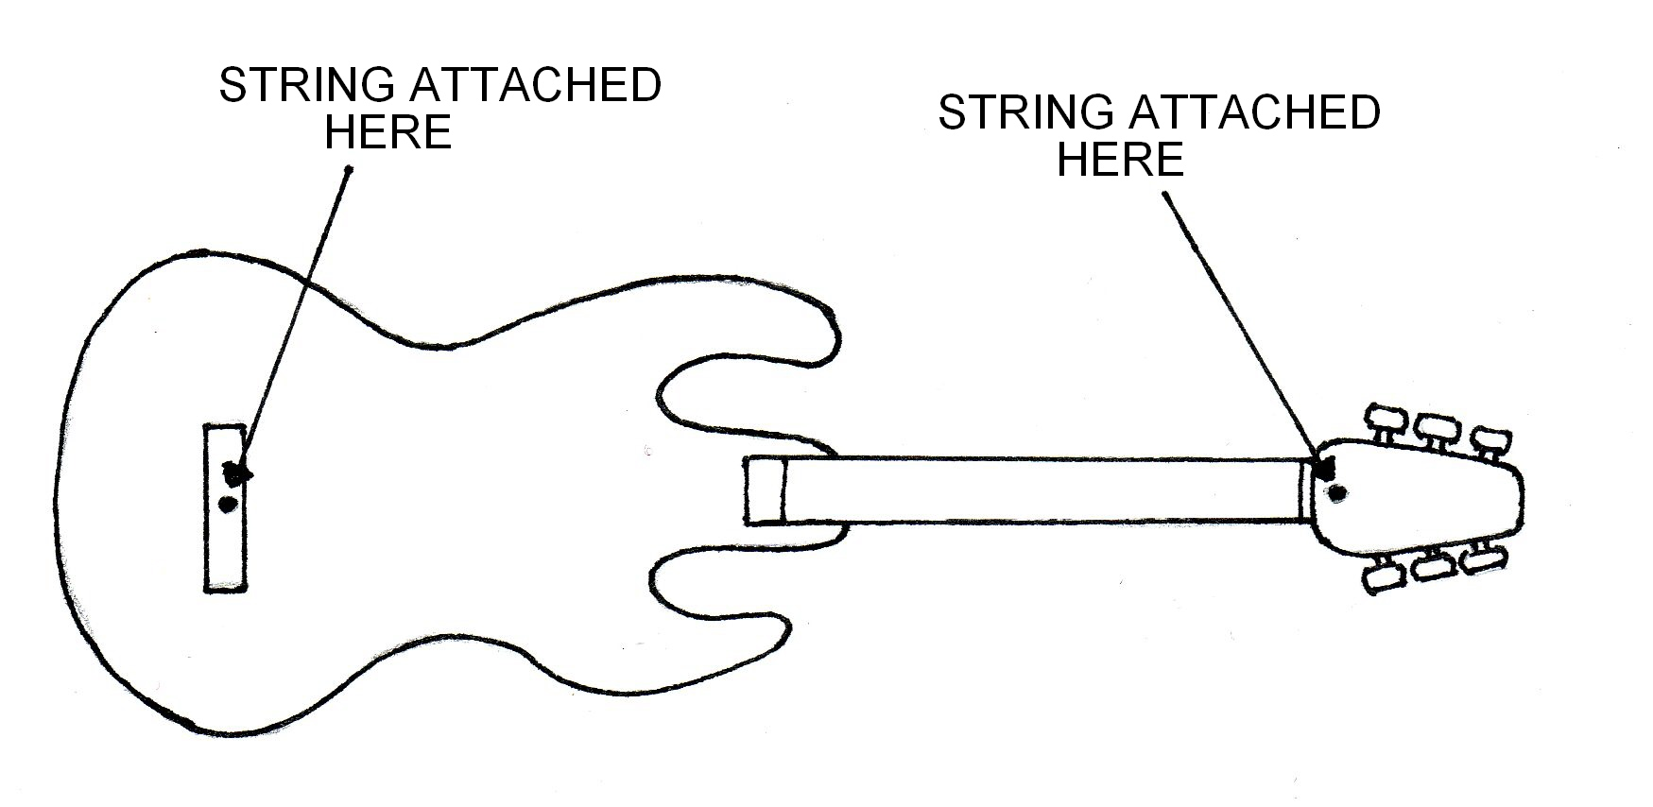

(b) What is the velocity of a transverse vibration that travels along the string?

- A student sets up a loudspeaker facing a smooth wall on a day when the temperature is 25ºC. The speaker is producing a single frequency sound and the sound is reflected by the wall. The student walks from the speaker to the wall and notices that there are loud regions of sound 2.75 m apart. Calculate the wavelength of the sound.

- Calculate the minimum velocity with which the bike rider can leave the ramp and still make the other side of the ditch.
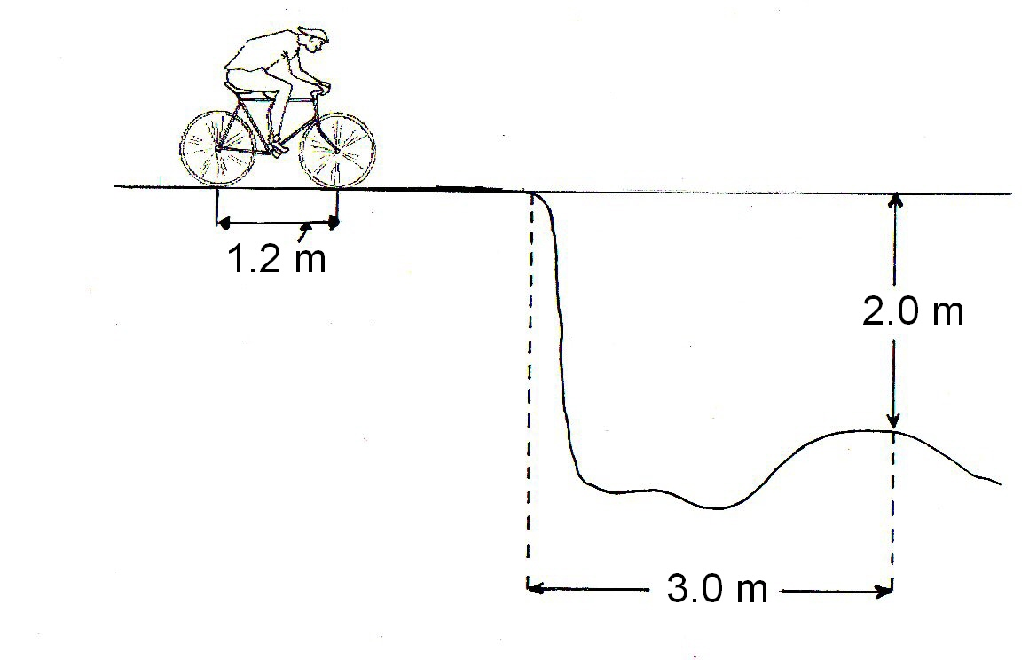

4 Explain why a communications satellite is more useful in a geosyncronous orbit but a weather satellite is more useful in a polar orbit.

5 An electron with kinetic energy of 1.7 x 10 ⁻¹⁸ J enters a magnetic field of 6.00 x 10⁻⁵ T. If the initial direction of the electron is perpendicular to the field, what is the radius of curvature of the electron as it travels through the field?

6 A canoeist paddles at a constant velocity from one bank directly across a river which is flowing at 3.5 ms ^{– 1}. If the canoeist is travelling at 1.5 ms ^{– 1} and the river is 35.0 m wide, what is the displacement when he reaches the opposite bank of the river?

7 When examining spectra emitted by the sun and an electric light globe with a sensitive spectrometer, a student noticed there were differences between the two spectra. Describe the differences the student would observe.

8 The aeroplane shown is travelling horizontally at 95.0 m s^{–1}. It has to drop a crate of emergency supplies. The air resistance acting on the crate may be neglected.
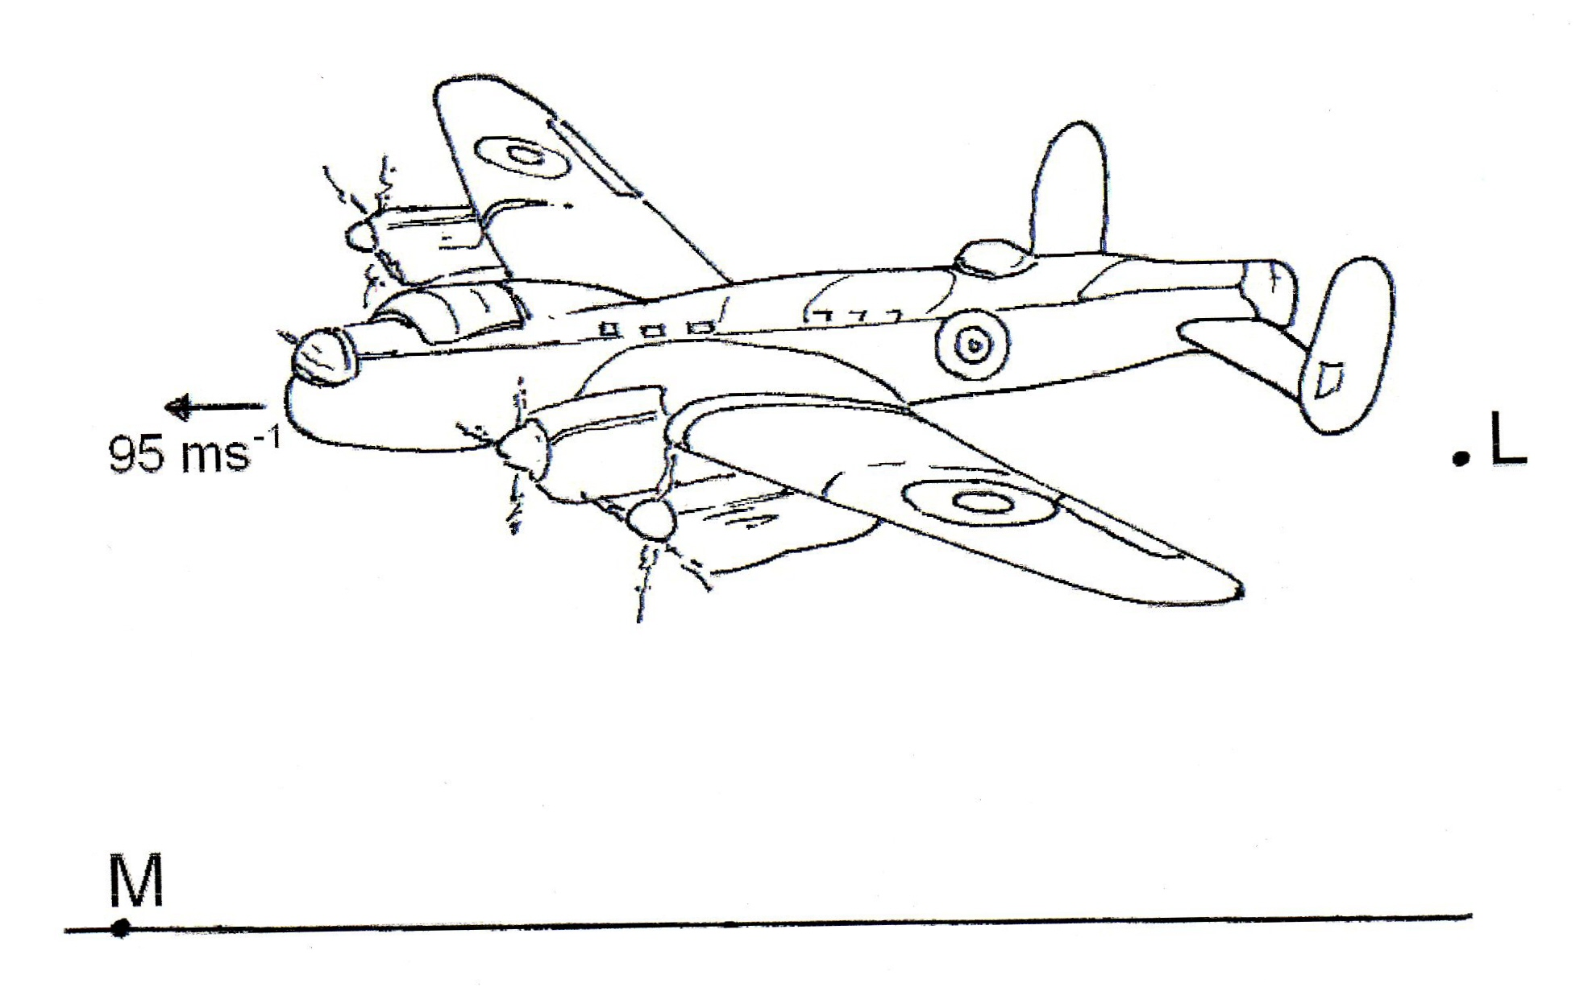

(i) The crate is released from the aircraft at point L and lands at point M. Sketch the path followed by the crate between L and M as seen from the ground.

(ii) Explain why the horizontal component of the crate’s velocity remains constant while it is moving through the air.

(iii) To avoid damage to the crate, the, maximum vertical component of the crate’s velocity on landing should be 32.0 m s^{–1}. Show that the maximum height from which the crate can be dropped is approximately 52 m.

- A truss is a device that is used in buildings to add rigidity to a structure. Two designs of trusses (A and B) are illustrated below. Explain in terms of the force components which truss is likely to be more rigid.
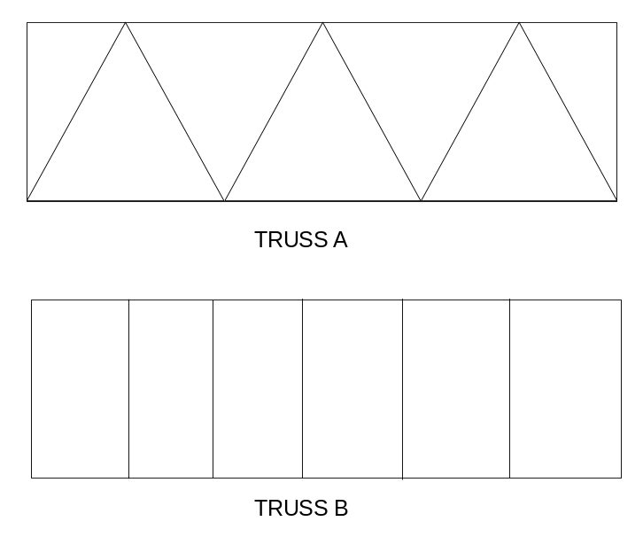

- The induction cooker, shown below, uses a frequency transformer to change the mains frequency of 50 Hz to 25 000 Hz so it can operate efficiently.

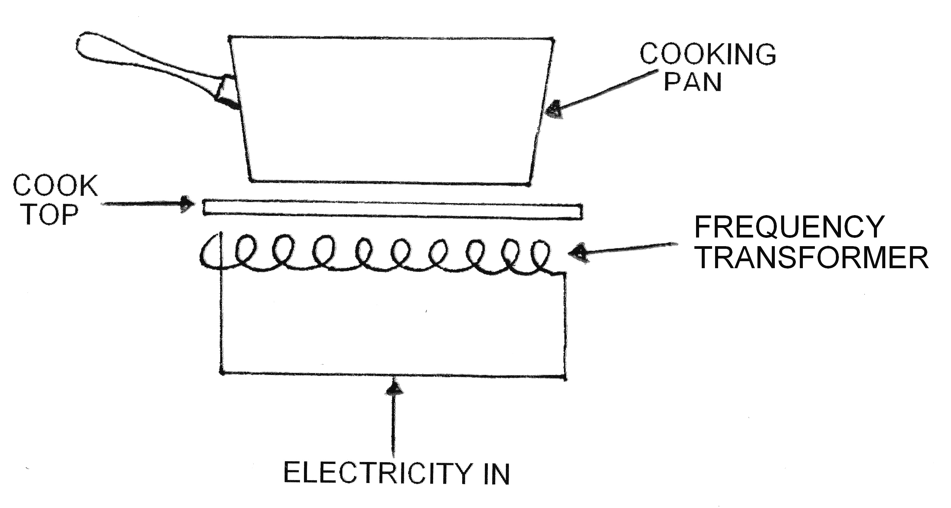

(a) Why does the frequency need to be increased to 25 000 Hz?

(b) Why does the cooking pan need to be made of an electrical conductor?

- An adventurous year 12 student hangs from the ceiling of the classroom by a wrought iron wire that has across sectional area of 2.0 x 10⁻⁵ m².
ESTIMATE how much longer the wire will be when he hangs on the wire.
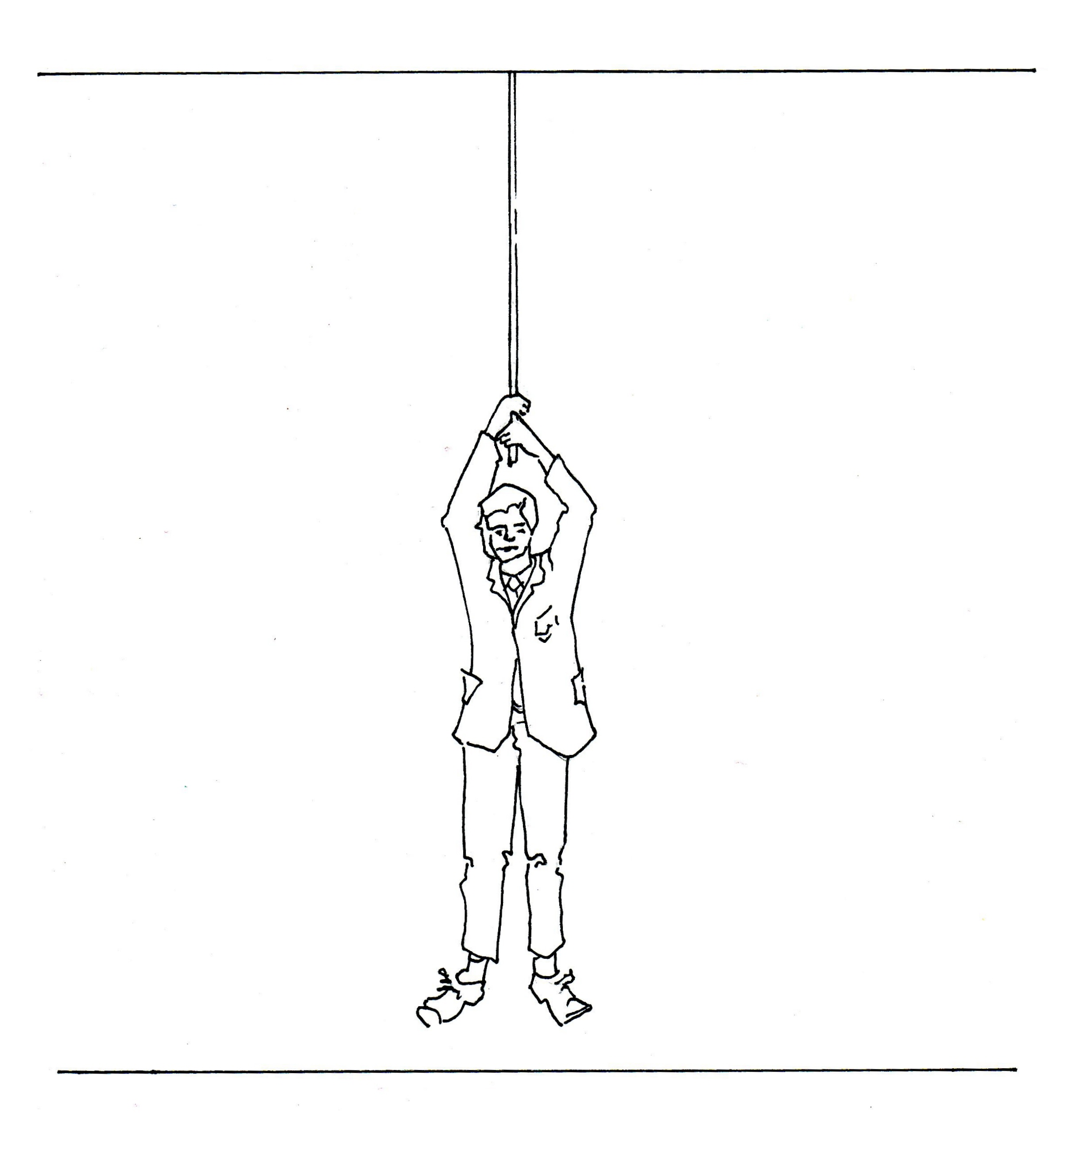

12 A small bar magnet is pushed through a long solenoid from left to right as shown in the diagram.
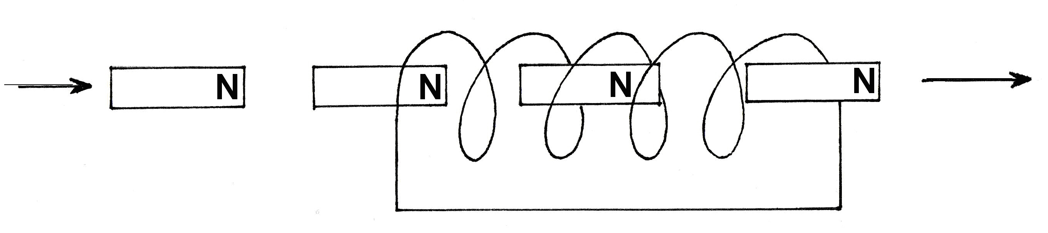

On the diagram show the following:
a The direction of the current induced in the solenoid. (label it A)
b The polarity (north or south) of the solenoid at the left hand end as the magnet enters the solenoid. (label N or S)
c The direction of the force on the magnet as it leaves the right hand end of the solenoid. (label it C)
d The direction of the force on the magnet when it is in the centre of the solenoid. (label it D)

13 A loudspeaker is producing a sound of 60 dB when a second speaker is switched on
producing 70 dB. What is the total decibel reading?

14 Figure 1a shows a glass vase standing on a shelf. Figure 1b shows an identical vase filled with water.
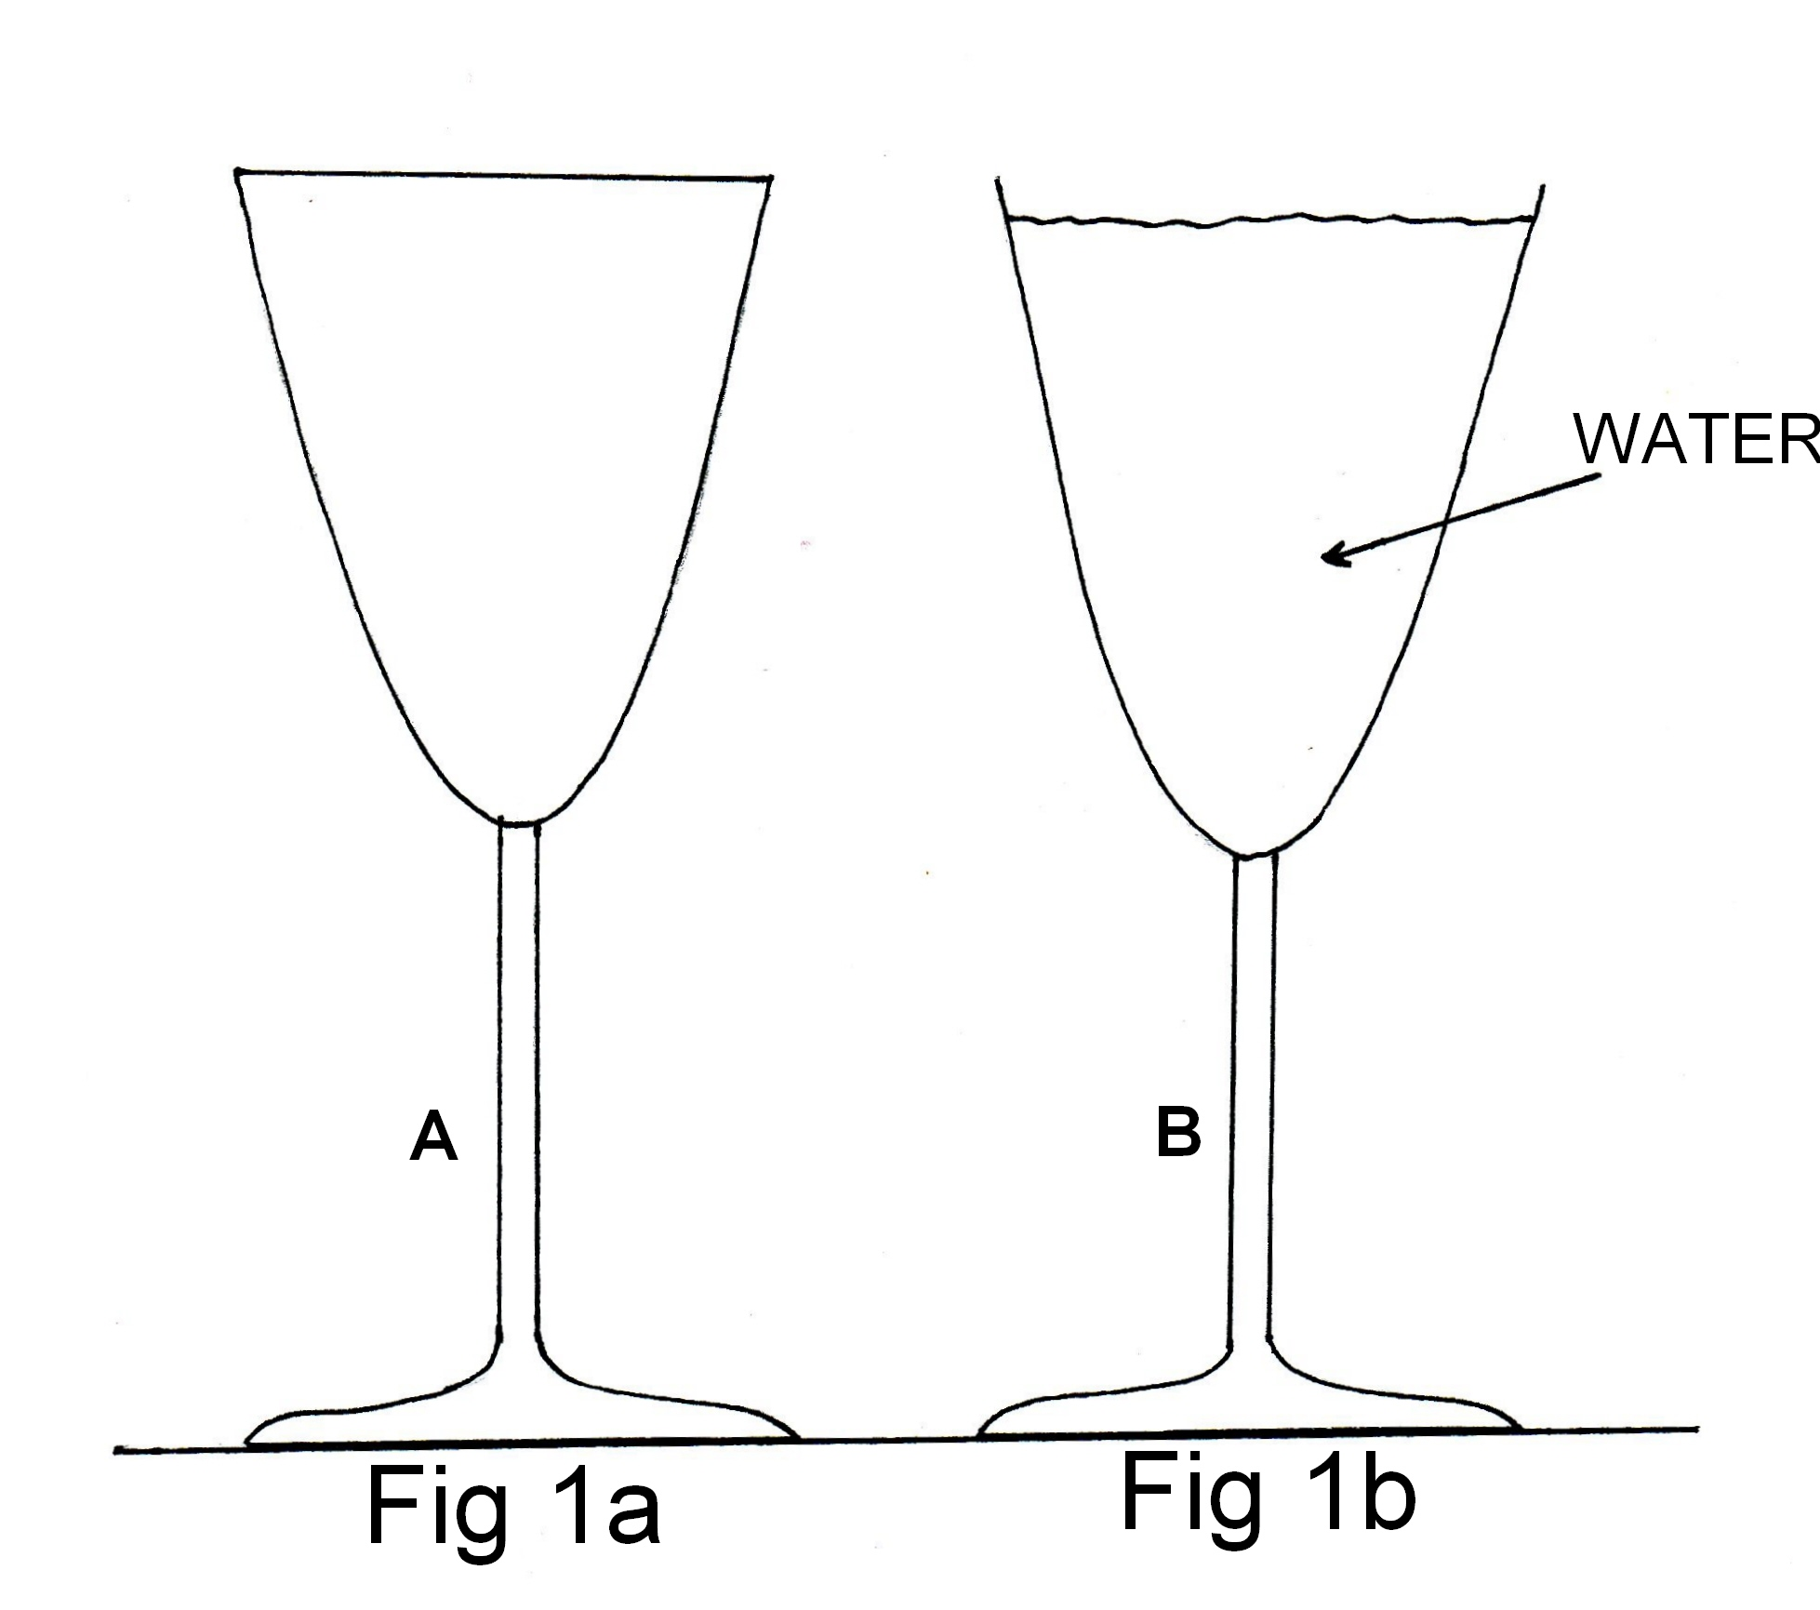

State which ornament (A or B) is more stable, and why. You should use Figures 1a and 1b to help your explanation.

15 Some street lamps produce yellow/orange colour instead of the usual white light.
Explain how these lamps are able to emit this coloured light.

Section B: Problem Solving

Marks allotted: 100 marks out of a total of 200 (50%).

This section contains 8 questions.

You should answer: ALL of the questions.

Answer the questions in the spaces provided

- (15 marks)

(a) The wave-form below shows the note produced by a violin.

time

Carefully draw on the graph the same note, played at the same loudness, by a
flute. (2 marks)

b) A student models a trumpet by using a narrow tube, closed at one end. To investigate how this tube responds to sounds of various frequencies generated at one of the ends, he places a small loudspeaker connected to a signal generator at one end of the tube and a microphone connected to a sound level meter at the other, as shown below.

The signal generator is turned on and is adjusted to vary the frequency of the sound produced by the speaker, keeping the sound intensity constant. He records the intensity of the sound received by the microphone as the frequency is varied.
The variation of the sound intensity level as the frequency is varied is shown in the figure below (not to scale).
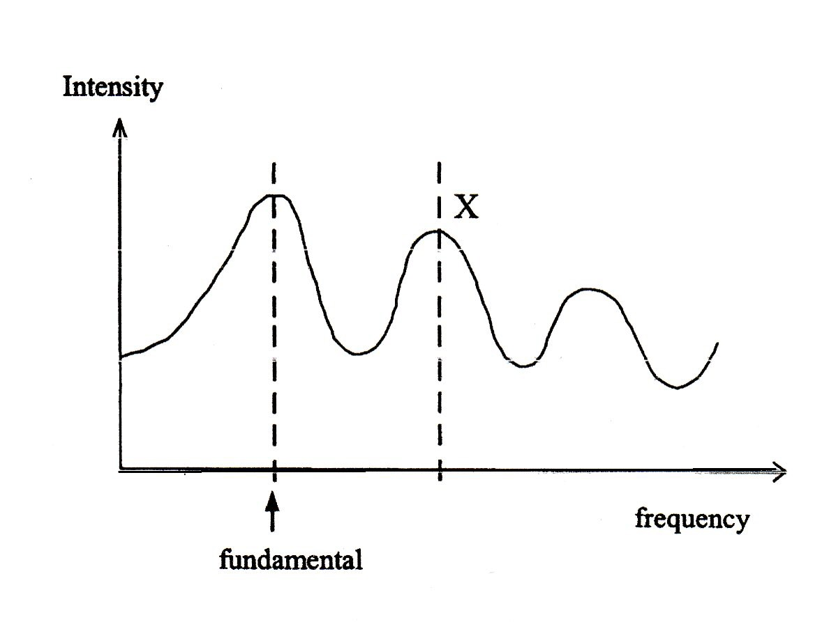

If the length of the tube is 65.4 cm, what frequency does the peak at X correspond to? (4 marks)

(c) In the representation of the closed tube below. Draw a displacement versus distance diagram of the wave form of the third harmonic. (2 marks)



(d) If the seal at the closed end of the tube was now removed thus making it an open tube, at what frequency would the tube resonate when it was resonating at its second harmonic? (4 marks)

(e) A standing wave is set up in the closed tube. What are the conditions for a standing wave to occur? (3 marks)

- (11 marks)
A female athlete threw the javelin at the 2006 Commonwealth Games in Melbourne a horizontal distance 65.25 m. The javelin left her hand at an angle of 33º to the horizontal from a height of 2.1 m above the ground.

a Why did throwing the javelin at an angle less than 45º produce a greater range? (2 marks)

b If V_{o} is the velocity with which the javelin left her hand, write an expression for the horizontal component of the velocity in terms of V_{o} and the angle. (1 mark)

c If V_{o} is the velocity with which the javelin left her hand, write an expression for the vertical component of the velocity in terms of V_{o} and the angle. (1 mark)

d Using the expressions from (b) and (c) above, calculate the velocity with which the athlete needs to throw the javelin to achieve a horizontal distance of 62.25 m. (magnitude and direction) (7 marks)

- (10 marks)
The figure below shows a sail boat. The mast is a uniform pole of 175.0 kg and is
4.88 m long. It is supported by the deck and held in position by front and back stays as shown. The tension in the front stay is 1 000.0 N.
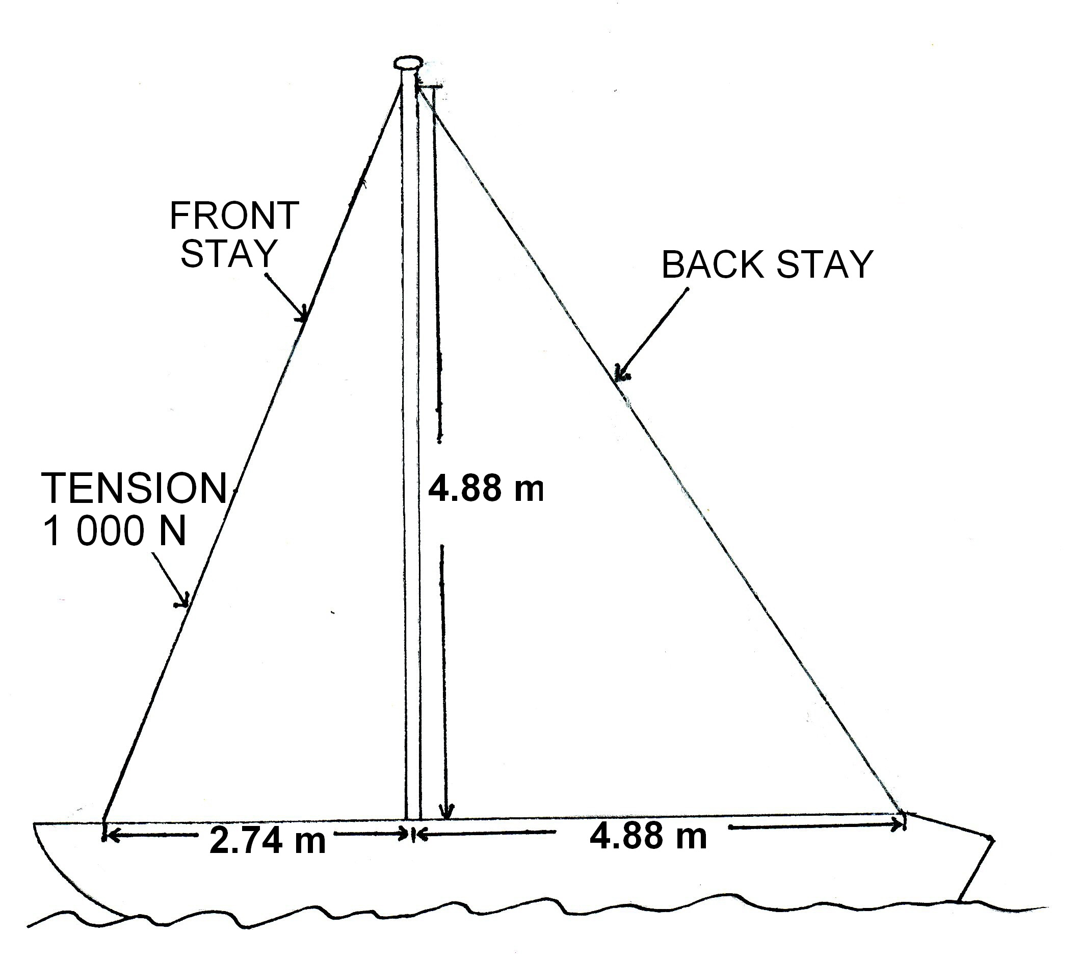

a) Calculate the tension in the back stay. (4 marks)

  - Determine the magnitude of the force that the deck exerts on the mast.
(4 marks)

c) Is there a tendency for the mast to slide towards the front or towards the back of the boat? Explain your answer. (2 marks)

4 (15 marks)
Consider the following diagram that shows the same collection of minerals in (a) daylight and (b) “black light”.

GREEN
BROWN
BLACK
GREY
BLUE
YELLOW

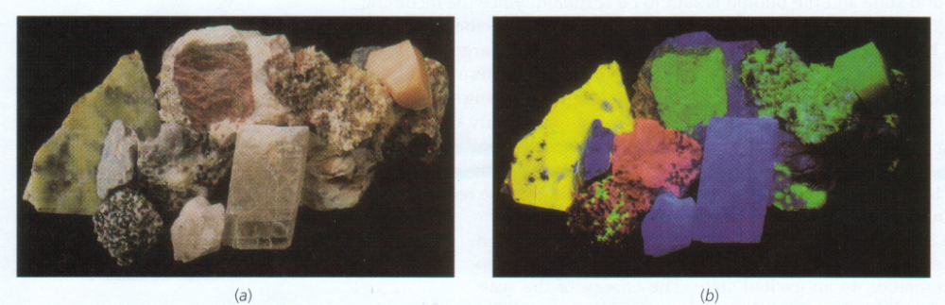
BLUE
BLUE
BROWN
BROWN

a) Complete the following sentence: The correct terminology for “black light” is

___________________________ and the phenomenon is called

___________________________. (2 marks)

  - The first 4 energy levels for a potassium mineral are shown (not to scale) as follows.

___________________________E₄ = 3.29 eV

___________________________E₃ = 2.61 eV

___________________________E₂ = 1.52 eV

___________________________E₁ = 0.00 eV

Could a sample of this potassium mineral display the phenomen in shown in (a) above? Justify your answer showing the necessary calculations. (4 marks)

c) Consider again the first 4 energy levels for the potassium mineral in (b).
What would be detected if particles of the sample were bombarded by

(i) photons of energy 2.65 eV;

(ii) electrons of energy 2.65 eV? (4 marks)

d) If an electron was excited from the ground state to the 3.29 eV level:

(i) When it returned to the ground state what would be the frequency of the photon emitted? (3 marks)

(ii) To which region of the electromagnetic spectrum would the photon belong? Support your answer by referring to its wavelength or frequency
(2 marks)

5 (12 marks)
The trains on the Perth to Fremantle rail line are powered by four 600.00 V d.c. motors. The current is delivered to the motors from the sub station overhead power lines which are at a potential of 2.5 x 10⁴ V a.c. The a.c. voltage needs to be converted to600.00V d.c. by a transformer.
The overhead lines have a resistance of 2.1 Ω km⁻¹and the motors each have a resistance of 2.00 Ω. When the train is close to the Perth sub station and operating at full power, the train draws 1.00 MW of electrical power.

(a) Why do overhead transmission lines operate at 25 kV a.c. and not at 600 V d.c.?
(2 marks)

(b) What is the current in the overhead lines when the train is close to the Perth substation and operating at full power? (2 marks)

(c) What is the starting current in ONE motor? (2 marks)

(d) If the train is 20 km from the substation the power developed by the train will be less than when it is close to the substation. If the train is now drawing 0.7 MW and the current drawn from the power lines is 28.0 A, then what is the voltage available to the motors? (6 marks)

6 (10 marks)
A crane lifts 7 x 10² kg load of concrete on a building site. The 8.0 m crane arm is uniform and has a mass of 3 x 10² kg. The cable used to raise and lower the load is attached to the crane arm 6.00 m along the arm
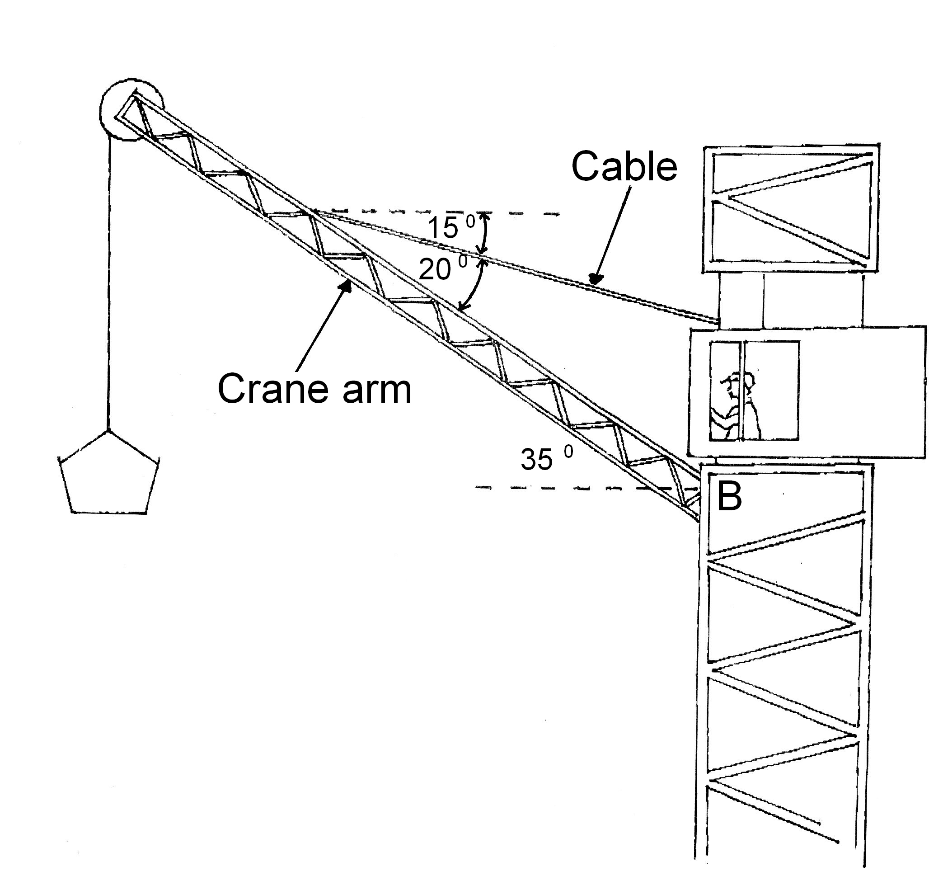

(a) Calculate the tension in the cable (4 marks)

(b) Calculate the reaction force at the base of the crane arm (B). (4 marks)

(c) At what angle to the vertical does the reaction force (B) act? (2 mark)

7 (15 marks)

The Global Positioning System (GPS) is a system of satellites that transmit radio signals that can be used to locate the position of a receiver anywhere on Earth.
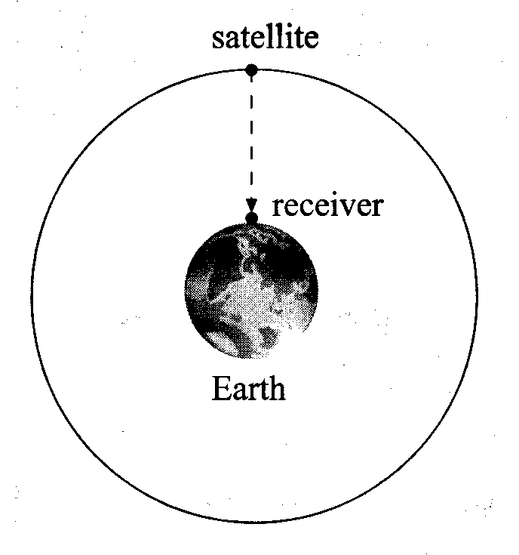
(a) A receiver at sea level detects a signal from a satellite in a circular orbit when it is passing directly overhead as shown in the figure above.

(i) The microwave signal is received 68 ms after it was transmitted from the satellite. Calculate the altitude of the satellite. (3 marks)

(ii) Show that the gravitational field strength of the Earth at the position of the satellite is about 0.56 m s^{–2}. (4 marks)

(b) For the satellite in this orbit, calculate

(i) its speed, (4 marks)

- its time period and hence the number of times the satellite orbits the Earth each day (24 hours)
(4 marks)

8 (12 marks)
A generator used to provide electricity for an outdoor party consists of a coil of 300 turns. The coil is 15 cm long and 10 cm wide. It is connected to a portable motor that turns the coil at a rate of 4 000 revolutions per minute. The magnetic field in the generator is 0.2 T.
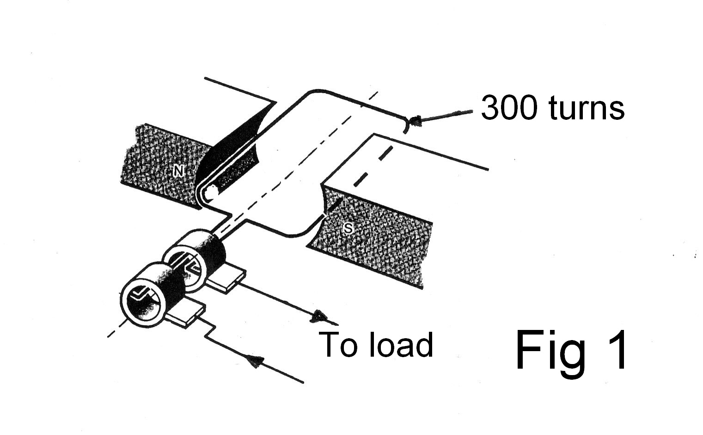

(a) Calculate the emf produced by the generator. (3 marks)

(b) If the generator had slip rings (see Fig 1) would the current produced by the generator be AC or DC? Explain your answer. (2 marks)

(c) List two ways in which the generator could be modified to produce a greater emf.
(2 marks)

(d) On the axis below draw a graph of the emf produced by the generator. Be sure to label the axis and provide a scale including units. (3 marks)
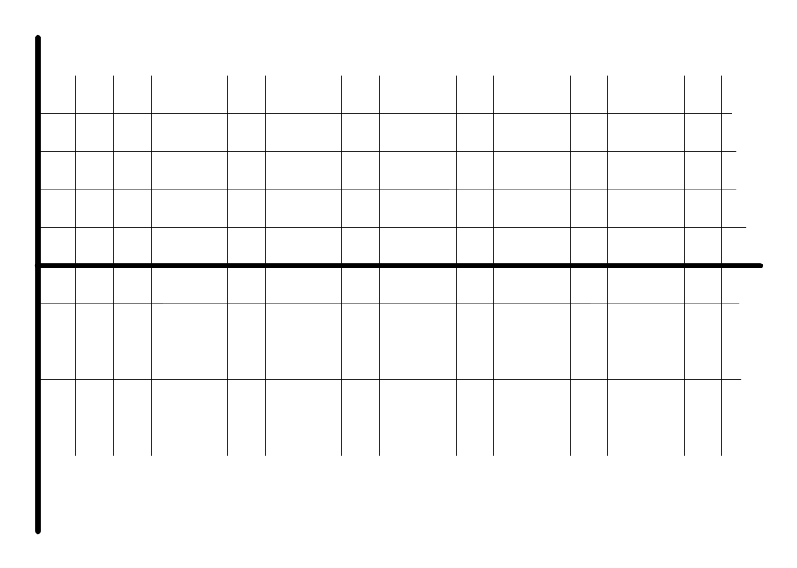

(e) Although the rate of rotation is quoted at 4 000 rpm, will the emf produced by the generator be a constant voltage? Explain your answer. (2 marks)

Section C: Comprehension and Interpretation

Marks allotted: 40 marks out of 200 (20%)

SECTION C: Comprehension & Interpretation
Marks allotted: 40 marks out of 200 marks total (20%)
BOTH questions should be attempted.

Read both passages carefully and answer all of the questions at the end of each passage. Candidates are reminded of the need for correct English and clear and concise presentation of answers. Diagrams (sketches), equations and/or numerical results should be included where appropriate.

Question 1 - Looking for Planet X
(para 1)
Marc Buie, eminent astronomer, has been studying the solar system beyond Pluto, among the swarm of small worlds called the Kuiper Belt. He has been looking at the very edge, about 50 times further out from the Sun than the Earth's orbit. Here, at the “Kuiper Cliff”, the number of astronomical objects drops off dramatically. He speaks of the possibility that some “massive object” has swept the zone clean of debris.

(para 2)
Other astronomers agree that there could be another large planet out there. Just how large has became clearer when computer models of the orbits of nearby objects predicted the kind of celestial object that could carve out the Kuiper Cliff and concluded that a planet about the mass of Mars or Earth would provide “a remarkable match” with the observations.

(para 3)
The last time the idea of a tenth planet created a stir was in 1983 , when planetary scientists began to realise that some comets were coming from a region not far beyond Neptune and Pluto. Since 2001, astronomers have discovered four KBOs (Kuiper Bell Objects) bigger than 1 000 kilometres across. Caltech astronomers announced the latest one, fully half the size of Pluto, in October 2001. They have provisionally called it Quaoar, after a native god of the indigenous dwellers of the Los Angeles region. Quaoar is over 1 200 kilometres across and orbits the Sun every 288 years.

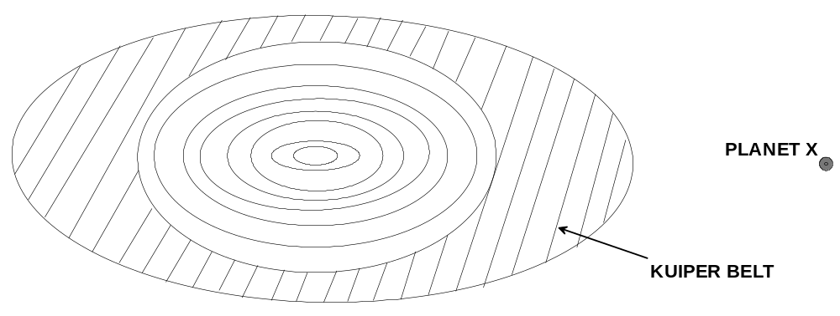
(para 4)
As well as containing the key to the origin of life, the Kuiper Belt, and Pluto in particular, may hold the key to how planets form Studying the craters on both Pluto and its moon Charon, for example, will reveal how KBOs have collided over billions of years-and provide clues to the way all the planets formed from smaller objects.

(para 5)
Pluto is only 2320 kilometres across, one-fifth the size of Earth. And the 1978 discovery that it is circled by a moon, Charon, whose diameter is 1270 kilometres, makes it even more distinct from the other planets we know about. Pluto and Charon make up a ‘twin planet’ - the only example in the Solar System.

(para 6)
In 2000, NASA scrapped its own Pluto-Kuiper Express mission on the grounds of expense. Under intense public pressure, it held a competition for universities and industry to design a cheaper, better mission. From this was born the New Horizons space probe, due for launch in December 2006. The mission's lead scientist, calculates that New Horizons will return 10 times more data than the cancelled Pluto-Kuiper Express, and at little more than half the cost.

(para 7)
Just over a year after the New Horizons’ launch, it will swing past Jupiter and pick up enough velocity to reach Pluto, possibly as early as July 2015. Indeed, by the time New Horizons reaches the Kuiper Belt, we may have confirmed that a new planet exists. Because of its vast distance from Earth, the only way we’ll find out for sure is to visit this new frontier of the Solar System and get a closer look.

QUESTIONS:

1. How is it possible that some “massive object” can sweep the zone clean of debris?
(3 marks)

2. Calculate the radius of the orbit of Quaoar about the Sun.
(4 marks)

3. If it is assumed that Quaoar is rocky and has the same density as the Earth, compare the mass of Quaoar with that of the Earth. [density = mass / volume and vol _{sphere} = 4/3 π r³]
(4 marks)

4. a) What property of Jupiter makes it ideal to use in the sling-shot” effect?
(1 mark)

b) The Voyager 1 spacecraft also used the sling-shot” effect in 1979, when it travelled past Jupiter with its engines off, is shown in the following diagram.

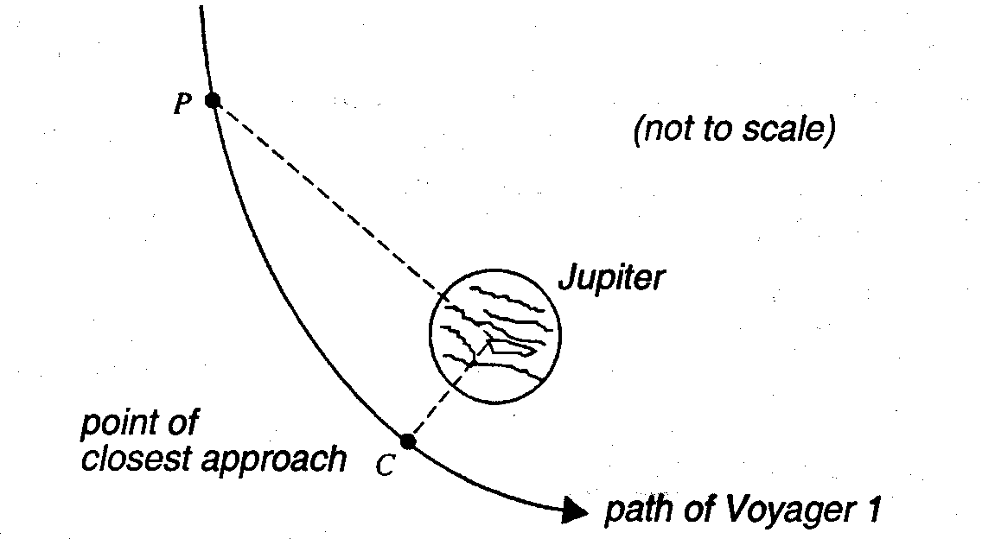

As Voyager 1 moved from point P to point C, the kinetic energy changed by 4.0 x 10¹¹ J. At point C, the point of closest approach, the force attracting the spacecraft to Jupiter was 6.4 x 10³ N.

The graph following shows how the force that attracted Voyager 1 depended on the distance from the centre of Jupiter.

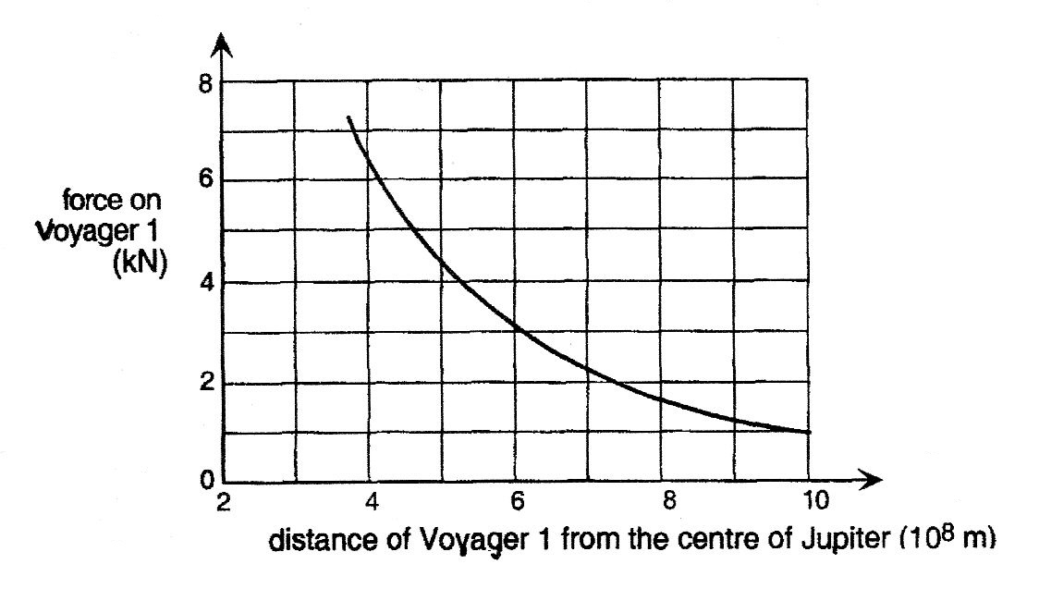

(i) Explain how you would use the information above to determine the distance of point P from the centre of Jupiter. (A numerical answer is not required.)
(3 marks)

(ii) Briefly explain why the answer to (i) above cannot be obtained using the standard formulae.
(1 mark)

5. If the distance between the centres of Pluto and Charon is about 21 000 km and the mass of Charon is about one-sixth that of Pluto, determine the position of the centre of mass of the Pluto – Charon system, about which they both rotate.
(2 marks)

6. Do you believe that the New Horizons space probe mission should go ahead? Explain briefly.
(2 marks)

Question 2

The following articles explain three types of induction. (i) Mutual induction (ii) Self induction and (iii) Electromagnetic induction.

(para 1)
(i) Mutual induction.
If two coils are placed near each other as shown in figure 1, a changing current in coil A will induce an e.m.f. in coil B. According to Michael Faraday the e.m.f. is proportional to the rate of change of flux passing through, or linked with it, and, since the flux is proportional to the current in coil A, the e.m.f. must be proportional to the rate of change of current in coil A.
i.e. e.m.f is α ΔI / Δt
and e.m.f is = to -M ΔI / Δt
The minus sign is due to Lenz’s law and M is called the mutual inductance of the two coils. It is sometimes said that Lenz’s law is a result of the law of conservation of energy, since energy cannot be created.

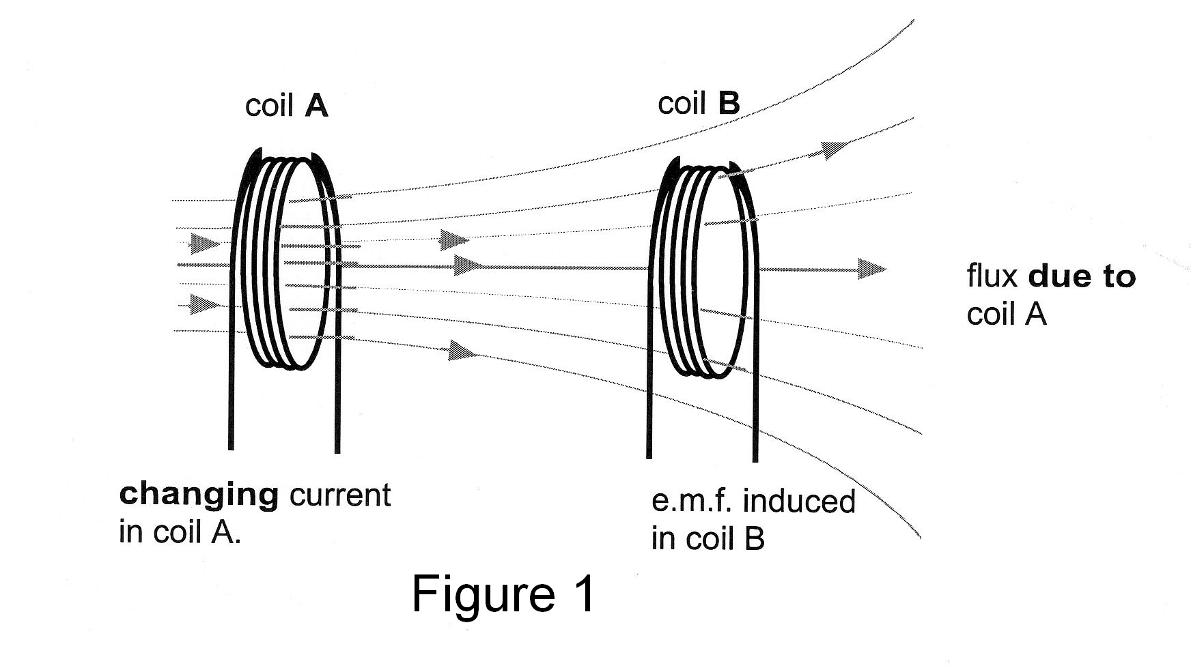

(para 2)
The magnitude of the induced e.m.f. in coil B depends on the size and separation of the coils and also on the number of turns in (i) coil A, which produces the flux, and (ii) coil B, the turns of which are in series. The presence of an iron core through both coils effects on the size of the induced e.m.f. Mutual inductance is made use of in pacemakers, which are used to control the flow of blood in the heart. Power in an external coil is transmitted via mutual inductance to a second coil in the pacemaker near the heart.

(para 3)
(ii) Self induction.
The concept of inductance also applies to an isolated single coil. When the current passing through a coil or solenoid changes, the flux associated with it also changes, and this induces an e.m.f. in itself. This e.m.f. opposes the changes to the flux and hence the current and the effect is to resist the changes in an alternating circuit. Lenz’s law states that any induced e.m.f. will always oppose the changes that are causing it. This means that the current does not rise and fall as much and the peak value will be less. Thus self induction has the same effect on an alternating current as resistance in a direct current circuit. It is self induction that limits the current in the primary of a transformer, which has very low electrical resistance to reduce energy wastage. If a direct current source is connected to a transformer the
primary almost always melts.

(para 4)
(iii) Electromagnetic Induction.
Many microphones work on the principle of induction. In one form, a microphone is just the inverse of a loudspeaker where a small coil, connected to a diaphragm, is suspended close to a permanent magnet. The coil, which is very light, moves in the uniform magnetic field when the sound waves strike the membrane and the frequency and waveform of the e.m.f. induced will be caused by the sound wave that moves the diaphragm. (see figure 2).
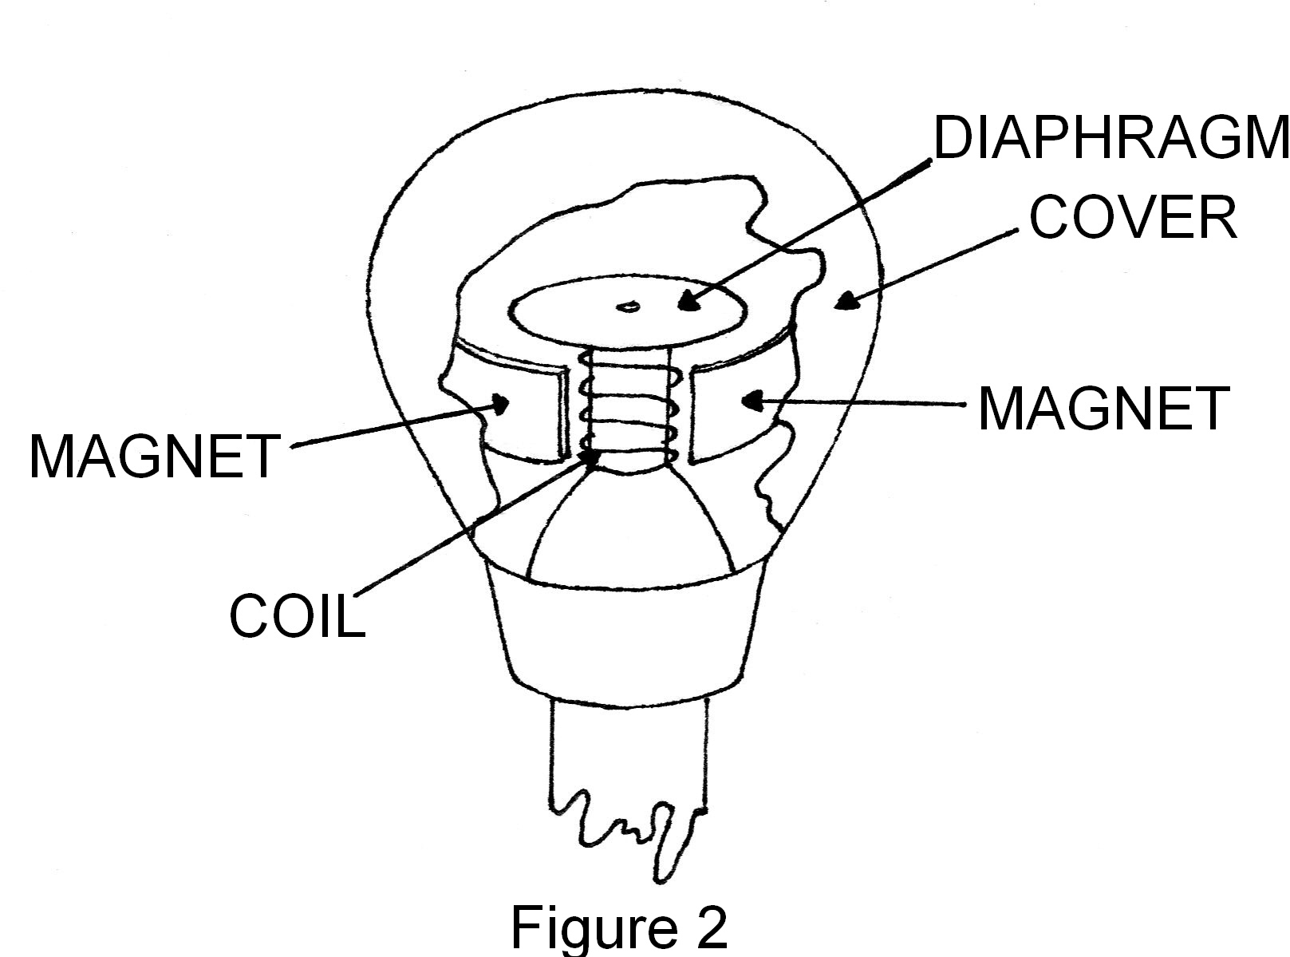

(para 5)
In a ribbon microphone a thin metal ribbon is suspended between the poles of a magnet and this vibrates in response to sound waves. The e.m.f. is proportional to the velocity of the ribbon or coil.

(para 6)
Electromagnetic induction is also made use of in the study of the earth’s crust. A device called a seismograph is used by geophysicists to monitor movements in the earth’s crust. The device is placed in direct contact with the Earth’s surface. When it detects movement in the earth the movement is converted into an electrical signal. In another field, geophysics, an important device called a seismograph is based on induction. A seismograph is placed in direct contact with the earth and converts the motion of the earth - whether due to an earthquake or an explosion - into an electrical signal.

(para 7)
It contains a magnet and a coil of wire. The coil is fixed rigidly to the case, which moves as the earth moves. The magnet is suspended from the case. In the type shown (see figure 3) the coil moves with the earth and the heavy magnet, which is suspended by springs which are not very stiff, remains stationary.
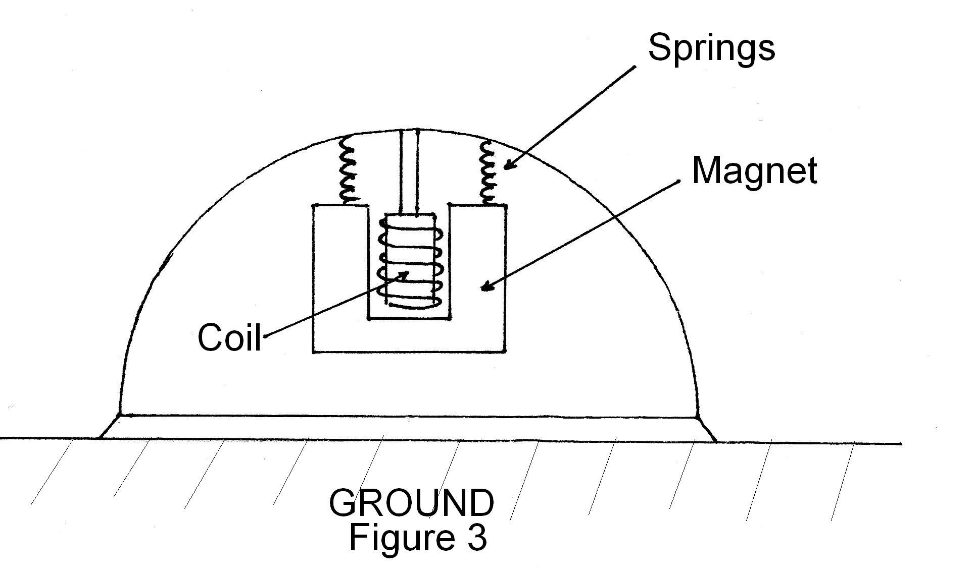

QUESTIONS

1 The e.m.f. in a ribbon microphone is proportional to the velocity of the
ribbon. What ‘principle’ does this involve and explain the connection? (3 marks)

2 Why must the magnetic field be uniform in the microphone? (2 marks)

3 Why is it important that a large magnet suspended on lightweight flexible
springs is used in the seismograph ? (3 marks)

4 Why does the number of turns in both of the coils affect the magnitude of
the e.m.f. in coil B ? (2 marks)

5 If in Figure 1, the flux through coil B, which has 1500 turns, is 3.4 x 10⁻² Wb
and this is reduced to 4.0 x 10⁻³ weber in 0.125 s; what is the magnitude of
the induced e.m.f. in coil B? (3 marks)

6 If there was a complete circuit, would the current in coil B would be
anti clockwise or clockwise, seen from the right. (1 mark)

7 Would a transformer make use of mutual or electromagnetic or self inductance for its operation? Explain your answer. (2 marks)

8 What is one advantage of the inductive pacemaker over a battery powered
pacemaker? (1 mark)

9 Why does a transformer coil melt if it is connected to a d.c. source? (3 marks)

END OF EXAMINATION

